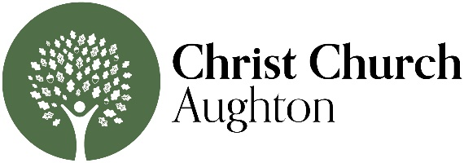

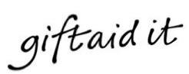
Gift Aid Declaration
If you are a UK taxpayer and eligible to Gift Aid your donation, please complete the
declaration below. This will increase your gift by 25p for every £1 given at no extra cost to
you or us. Thank you.

Please treat as Gift Aids donation all qualifying gifts of money made from the date of this declaration and in the past four years. I am a UK taxpayer and understand that if I pay less Income Tax and/or Capital Gains Tax than the amount of Gift Aid claimed on all my donations in that tax year, it is my responsibility to pay any difference.

Full Name: _________________________________________________________

Address: ___________________________________________________________

___________________________________________________________________

Postcode: __________________________________________________________

Signature: _________________________ Date: _____________________

NOTES

- Please notify us if you:
  - Want to cancel this declaration
  - Change your name or home address
  - No longer pay sufficient tax on your income and/or capital gains. Gift Aid is linked to basic rate tax, currently 20%, which allows charities to reclaim 25p for every £1 donated.

- If you pay Income Tax at the higher or additional rate and want to receive the additional tax relief due to you, you must include all your Gift Aid donations on your Self-Assessment tax return or ask HM Revenue and Customs to adjust your tax code.

Christ Church Aughton PCC is a Registered Charity, No 1129036
Please mail or drop off your completed form to:

Christ Church Ministry Centre
Long Lane, Aughton
L39 5AS
Attention: Mark Patterson or Jen Ray

Or via email:
treasurercca@outlook.com

